Kaplan Martinez
ITAI 1378
A02 "Image Processing Adventure Quest"
Realm 1 Challenge 2
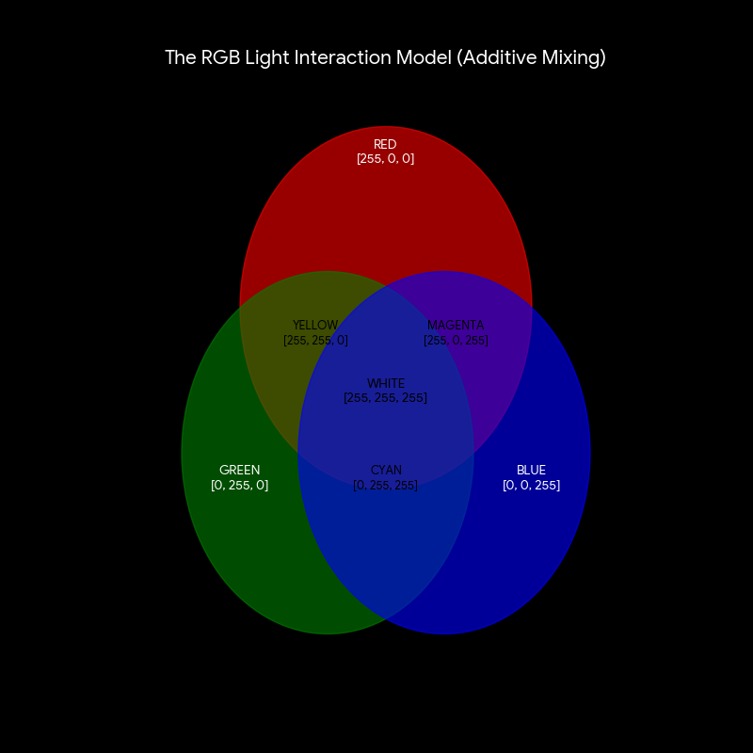
Aiden’s Journey into the Grid
Aiden, a freshman at HCC, sat in the lab staring at a screen full of Python code. He had just finished a lab on digital image representation when the monitor began to glow with an intense, blinding light. Suddenly, the room vanished.
He landed with a thud on a hard, checkered floor. Looking down, he realized he wasn't on a floor at all, he was standing on a giant square of pure red. Next to it was a square of deep black. He looked around and saw an endless grid extending to the horizon.
"Welcome to the Matrix," a voice boomed. A small, glowing floating point named Dot appeared. "Actually, it's just a 3D numerical matrix. You’re currently standing on Pixel (0,0)."
Aiden looked at the red square beneath his feet. "Why is it so bright?"
"Because your value here is 255," Dot explained, pointing to a floating number above the red zone. "In this RGB Realm, 0 is total darkness and 255 is full intensity. You're standing in the Red Channel."
Dot led Aiden across the grid to the RGB Forest, where three giant pillars of light colors red, green, and blue intersected. As the lights mixed, the ground changed from yellow to cyan to white. Aiden realized that by just changing the numbers in the matrix, the world around him could create over 16 million colors.
Suddenly, the atmosphere shifted. The rigid grid began to swirl into a circle. "We’ve entered the HSV Valley," Dot whispered.
Instead of three pillars, Aiden saw a great spinning wheel. A wizard named Hue stood in the center. "RGB is how the computer sees," the wizard said, "but I am how humans feel. I control the shade (Hue), how vivid the world is (Saturation), and how bright the sun shines (Value)."
With a snap of the wizard’s fingers, the Saturation dropped to zero, and the vibrant world turned into a gray, numerical wasteland, the Grayscale zone Aiden remembered from his lab.
"I get it now," Aiden said, looking at the numbers 0-255 swirling around him. "It’s not just a picture. It’s all just data."
The numbers began to spin faster, pulling Aiden back through the screen. He blinked, found himself back in the HCC lab, and immediately reached for his keyboard. He didn't just see pixels anymore; he saw the math behind the magic.

Quest Reflection
Doing this "Adventure Quest" actually helped me wrap my head around the stuff we did in the lab. In the lab, we were mostly looking at images as uint arrays and matrices in a Jupyter Notebook. It made sense on the screen, but writing the story about Aiden actually walking through the pixels made the "0 to 255" thing feel more real.
I approached the challenge by trying to connect the "traditional tools" we used, like OpenCV and Pillow, to something more visual. In the lab, we saw how color images are 3D matrices with different channels, so I used the "RGB Forest" in the story to represent those layers.
I learned that while RGB is the standard for how we code images in Python, the HSV model is a lot more intuitive for describing how we actually see color. The hardest part was trying to explain something technical like a "numerical matrix" in a way that sounded like a story, but it helped me realize that image processing is really just the foundation for the AI stuff I’m studying here at HCC. Overall, it was a cool way to see how the math we're learning turns into the stuff we see on our phones every day.

